Introduction

The website I’ll be making will be all about bikes.

The target audience will be the ones that are willing to buy a bike for someone or for themselves.

The user requirement is people wanting to buy bike and there’ll be different bikes like BMX and electric.

STORY BOARD:

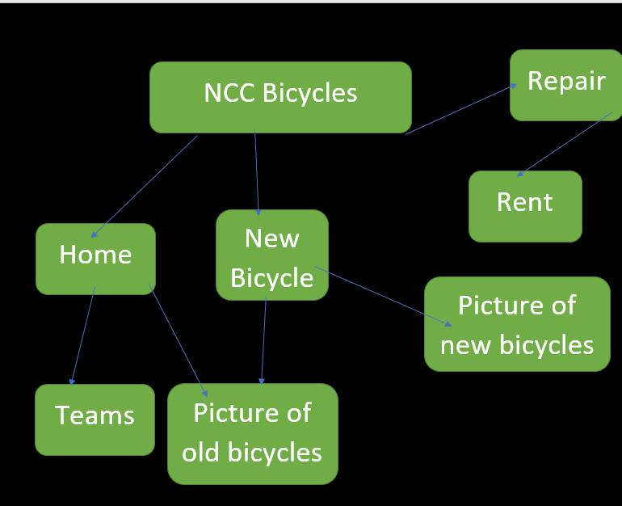

Asset Table

|  |  |  |  |  |  |  |
| --- | --- | --- | --- | --- | --- | --- |
| Source | Element name or image | P / S* | Details of permission if used | Element Description | Details of editing  (this is a very important part of the process, as this is where you will show how you have made the assets fit for audience and purpose) | In which part of the project have you used this asset? |
| Taken Picture from internet  <https://lh5.googleusercontent.com/p/AF1QipPdEkZDUhHnoE1m2molvwPolvg7R0Do0VzK6T4m=w408-h544-k-no> |  | P | Permission not required Public Place | Front of the college. | Image will be cropped and border will be added to the image. | Home Page |
| <http://blog.ixl.com/2012/09/25/how-do-you-manage-your-classroom/>  Taken from Internet |  | S | Website states that image can be used for personal or educational purpose. | Classroom with students. | Border will be added and image will be rotated. | About the College Page |
| <http://www.freesfx.co.uk/>  Taken picture from Internet |  | S | Can use sound free to download from website and choose any sound you want. | Sound effect of a drum beating. | Will use sound for 4secounds merged with voice over. | Video of Place of Interest |
| Taken Picture from Internet  <https://lh5.googleusercontent.com/p/AF1QipNoXiUHtjXuTuNHd1y2GOGatojA4eIU0uOU21YX=w408-h544-k-no> |  | P | Permission granted from the owner of the shop. | The front of the PFC shop. | Image shows | Place of Interest Page |
|  |  |  |  |  |  |  |
|  |  |  |  |  |  |  |

Website Development

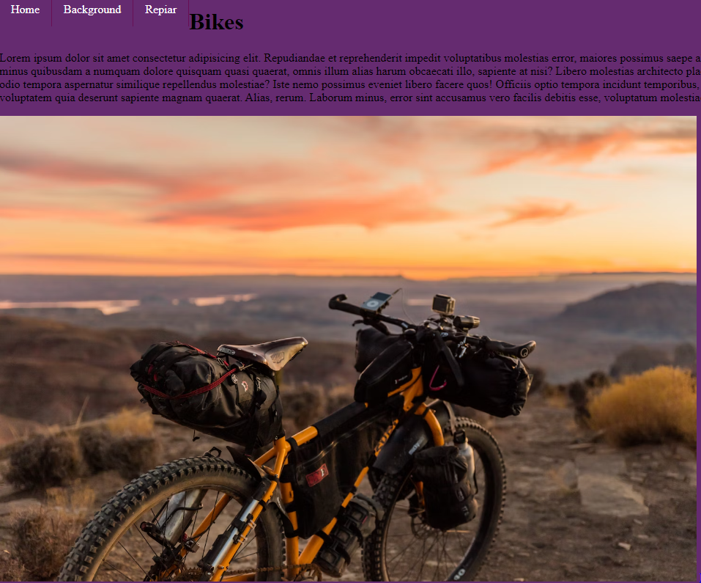

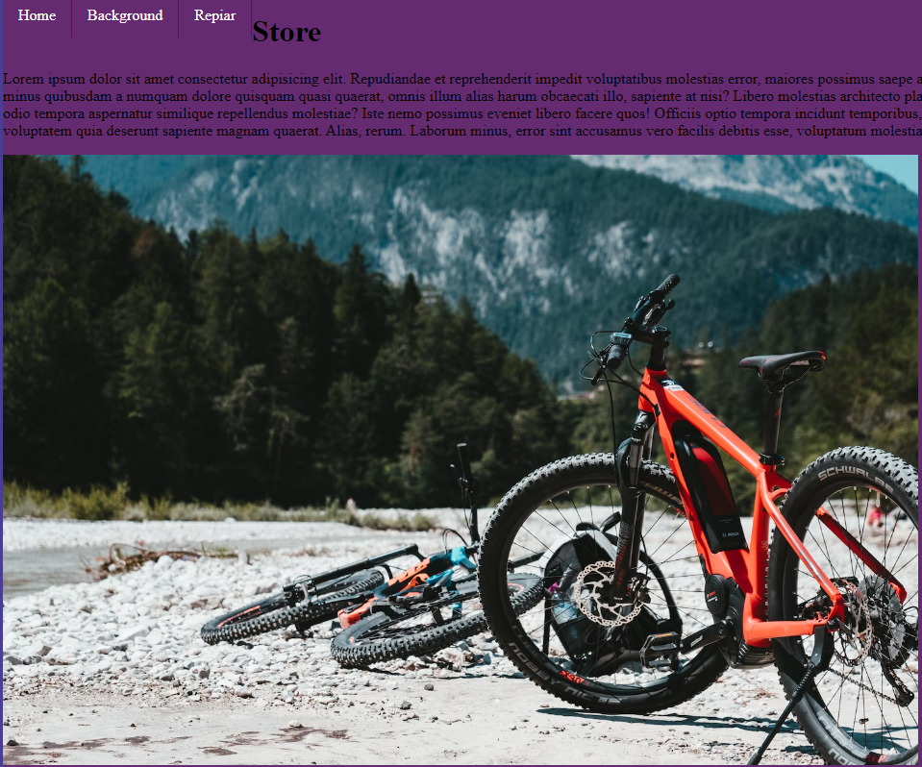

This is the store screen

This is the home screen

This is the background screen

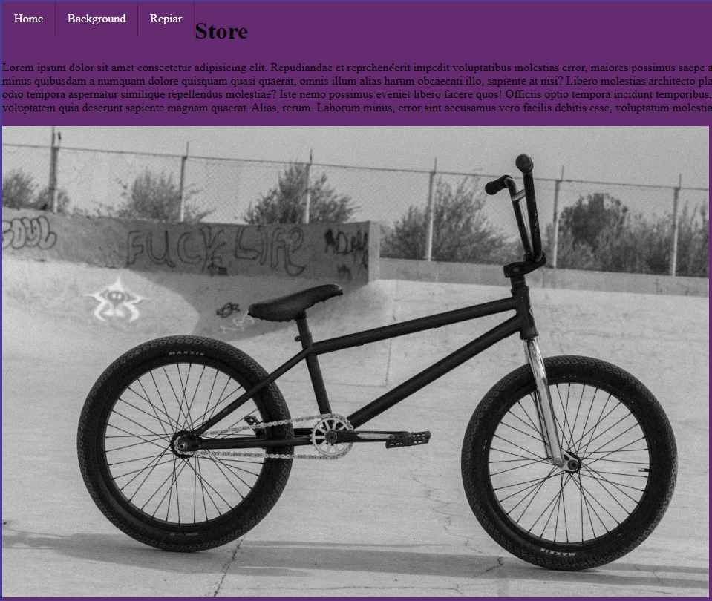

This is the repair screen

Test Plan

|  |  |  |  |
| --- | --- | --- | --- |
| Test Case | Expected Result | Actual Result | Action |
| Test all links are working fine | Links should work as per expected | Yes, they are working correctly | No Action |
| Test all images and they are crystal clear and visible | To be visible, nice and clean and clear | It worked out how I wanted. | No action |
| Test all buttons are secure and fine | To be able to work and take me to another link | It worked successfully but isn’t that satisfying. | No action |

Feedbacks:

1st Feedback

Anjum - The website looks good and the student has put in efforts to make it nice and attractive.

2nd Feedback

Kevin: The website is looks very good and the colours is very nice, its cool just need a bit of more colours.

Final Evaluation

My website is all about bikes and I tried my best to make it beautiful and clean as possible and it turned out very successful which is a big massive blessing for me and I am very proud of myself. It achieved the requirements.